Tutorial 12

Module Name: AI-Assisted Software Testing
Test Case ID: TC12
Tester Name: Vora Riya

Scenarios:
- Scenario: AI Prompt
Scenario
Open AI.
Test Steps
I am a software testing student doing a practical on AI-assisted testing.
Requirement: On the website https://www.saucedemo.com/, a user enters a username and password and clicks the Login button. A valid user should be redirected to the Products page. An invalid or locked-out user should see an error message, and empty fields should show a validation message.
Based on this requirement, please give me the following, in this order, each under its own heading:
- Test Cases: a table with the columns Test Case ID, Scenario, Steps, Expected Result.
- Test Data: a table with the columns Test Case ID, Username, Password, Expected Outcome. Include a valid user, invalid password, locked-out user, and empty fields.
- Defect Prediction: a table with the columns Defect, Possible Cause, Severity.
- Selenium Code: Python Selenium code using Chrome to test the valid login test case.
  - Use standard_user and secret_sauce.
  - Use explicit waits (WebDriverWait), not time.sleep.
  - Assert that the URL contains "inventory" after login.
  - Print "AI-Assisted Login Test: PASS" if it succeeds and "AI-Assisted Login Test: FAIL" if the assertion fails.
  - Close the browser in a finally block.

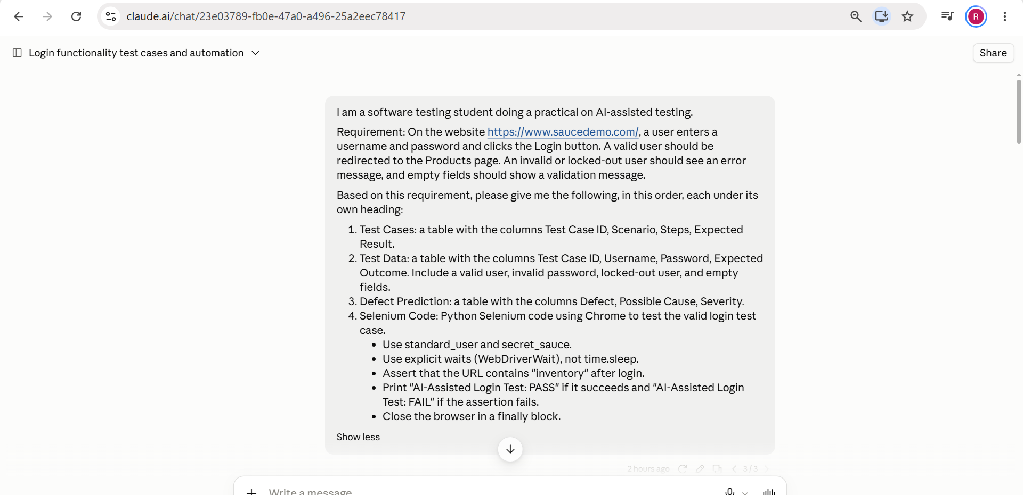

- Scenario: AI-generated test cases

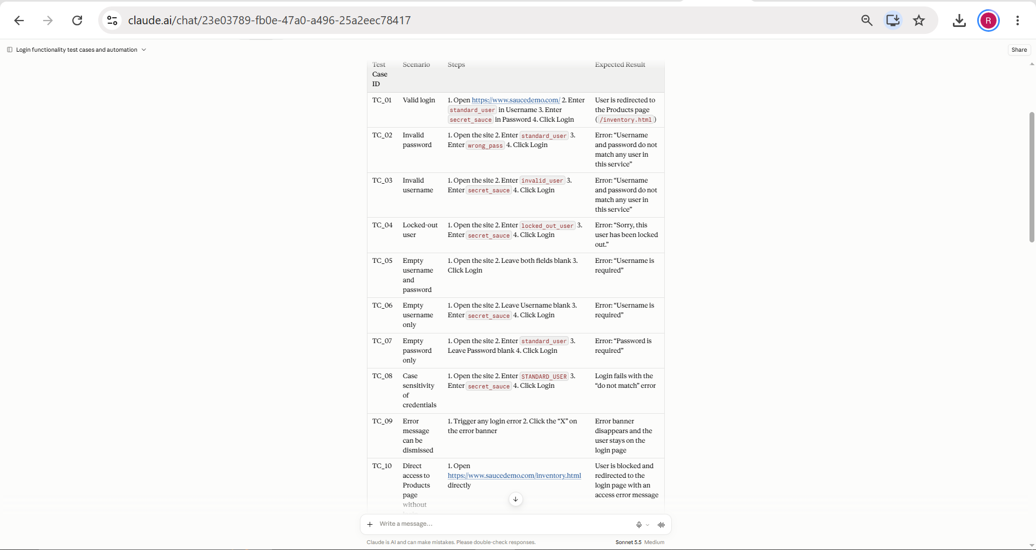

- Scenario : AI-generated test data
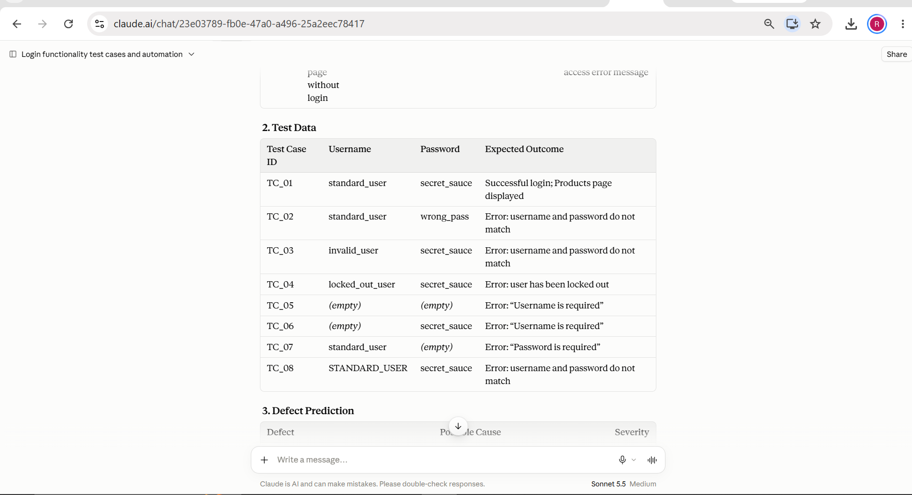

- Scenario : AI-generated code

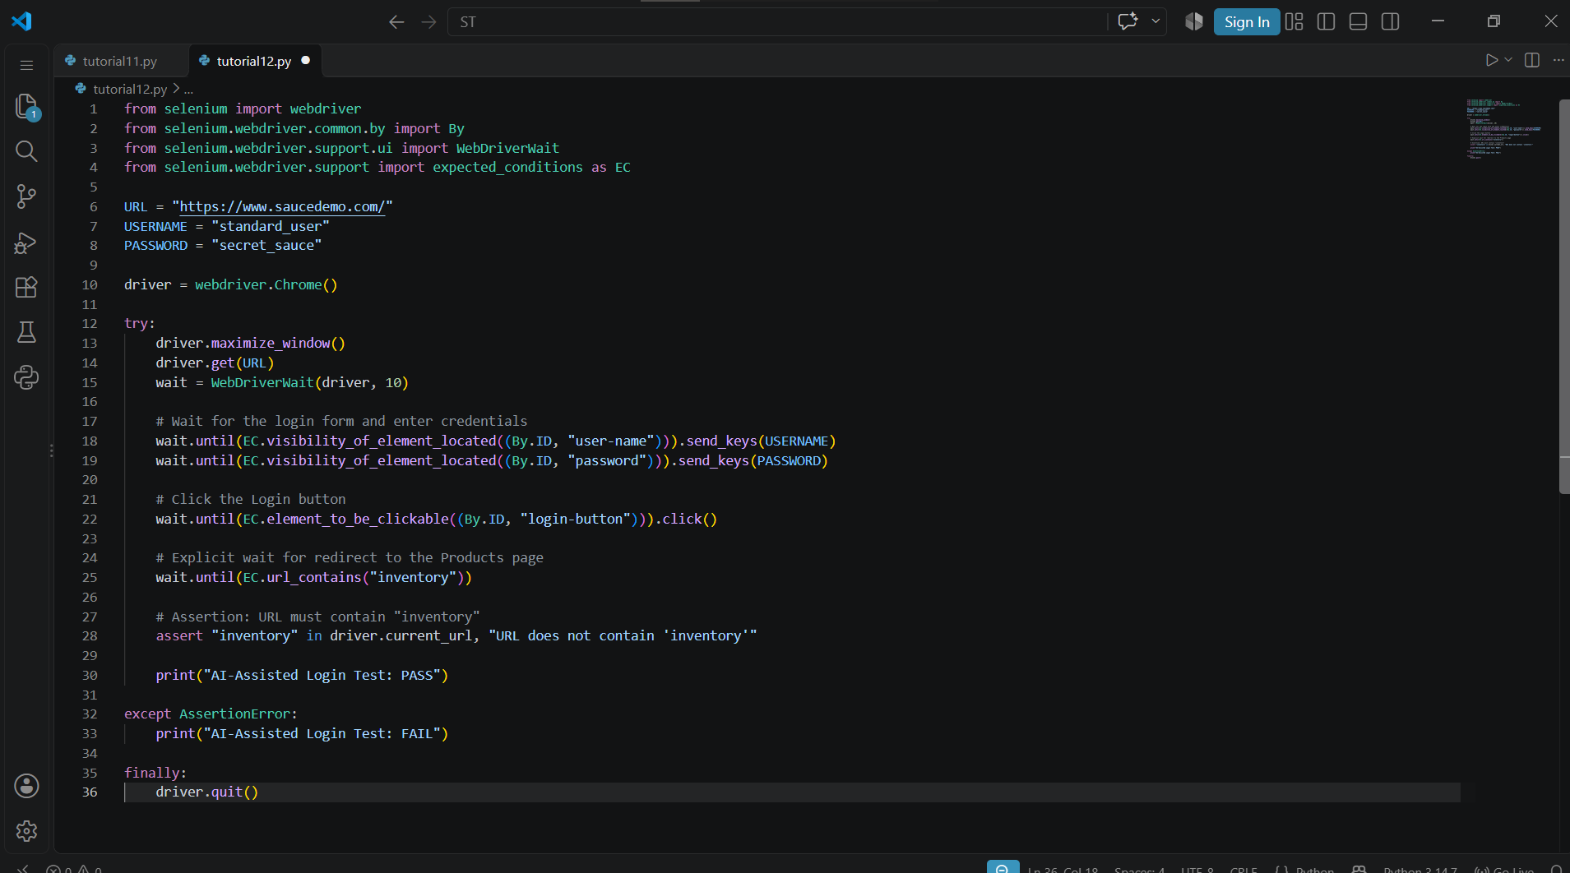

- Scenario : Corrected code in PyCharm
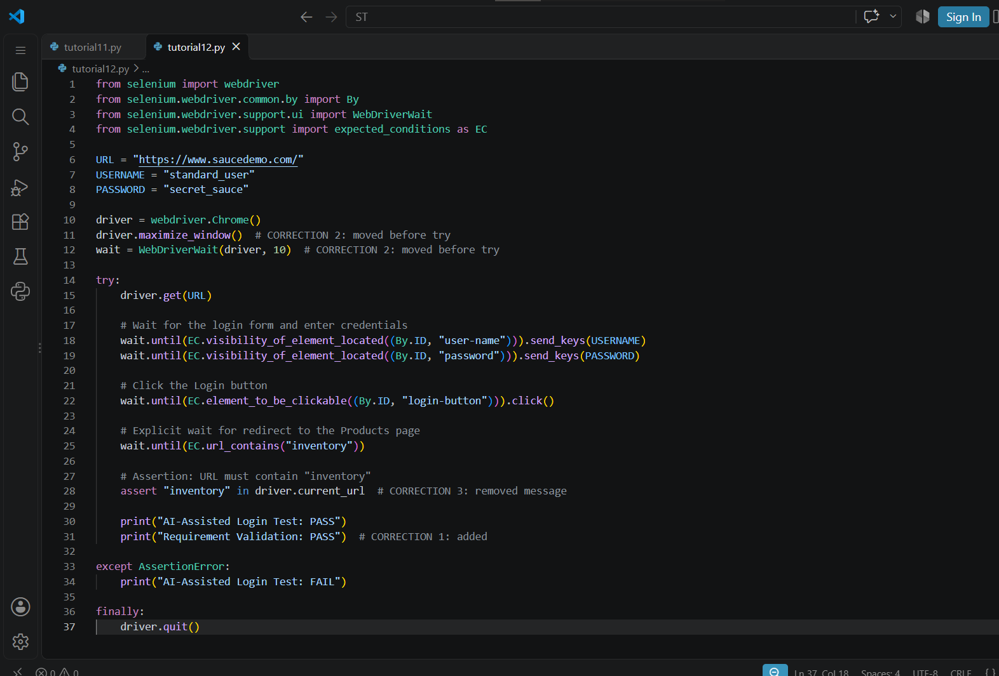
- Scenario : Browser output
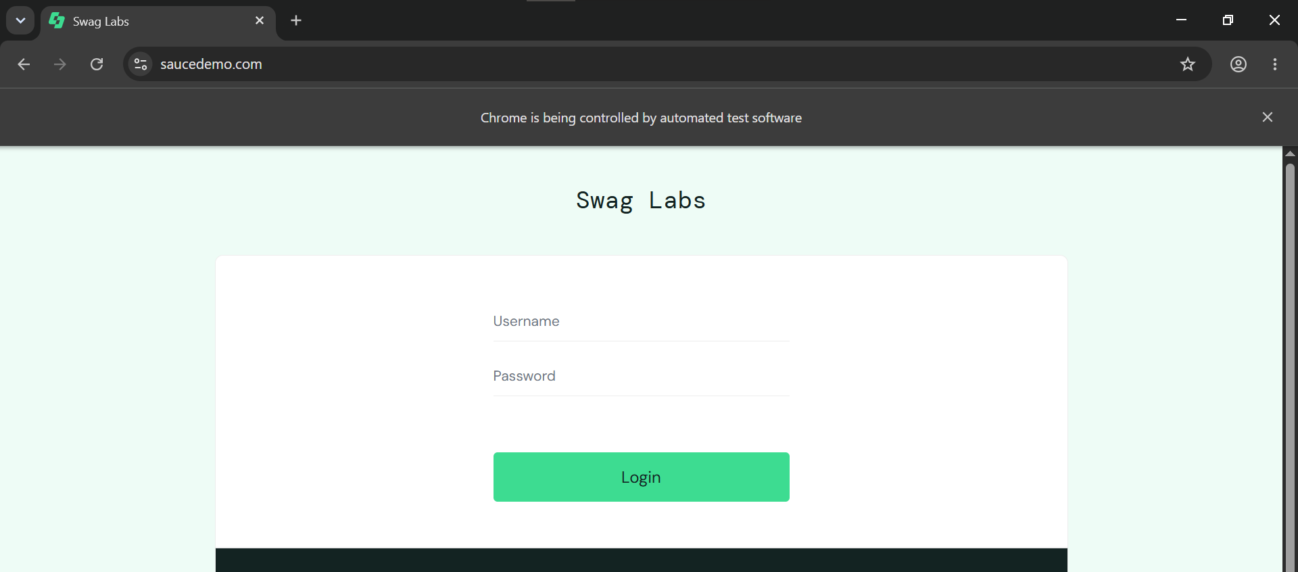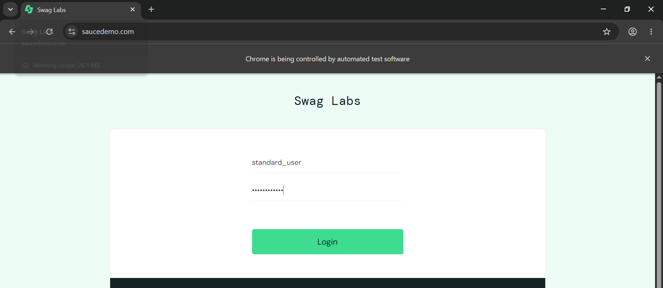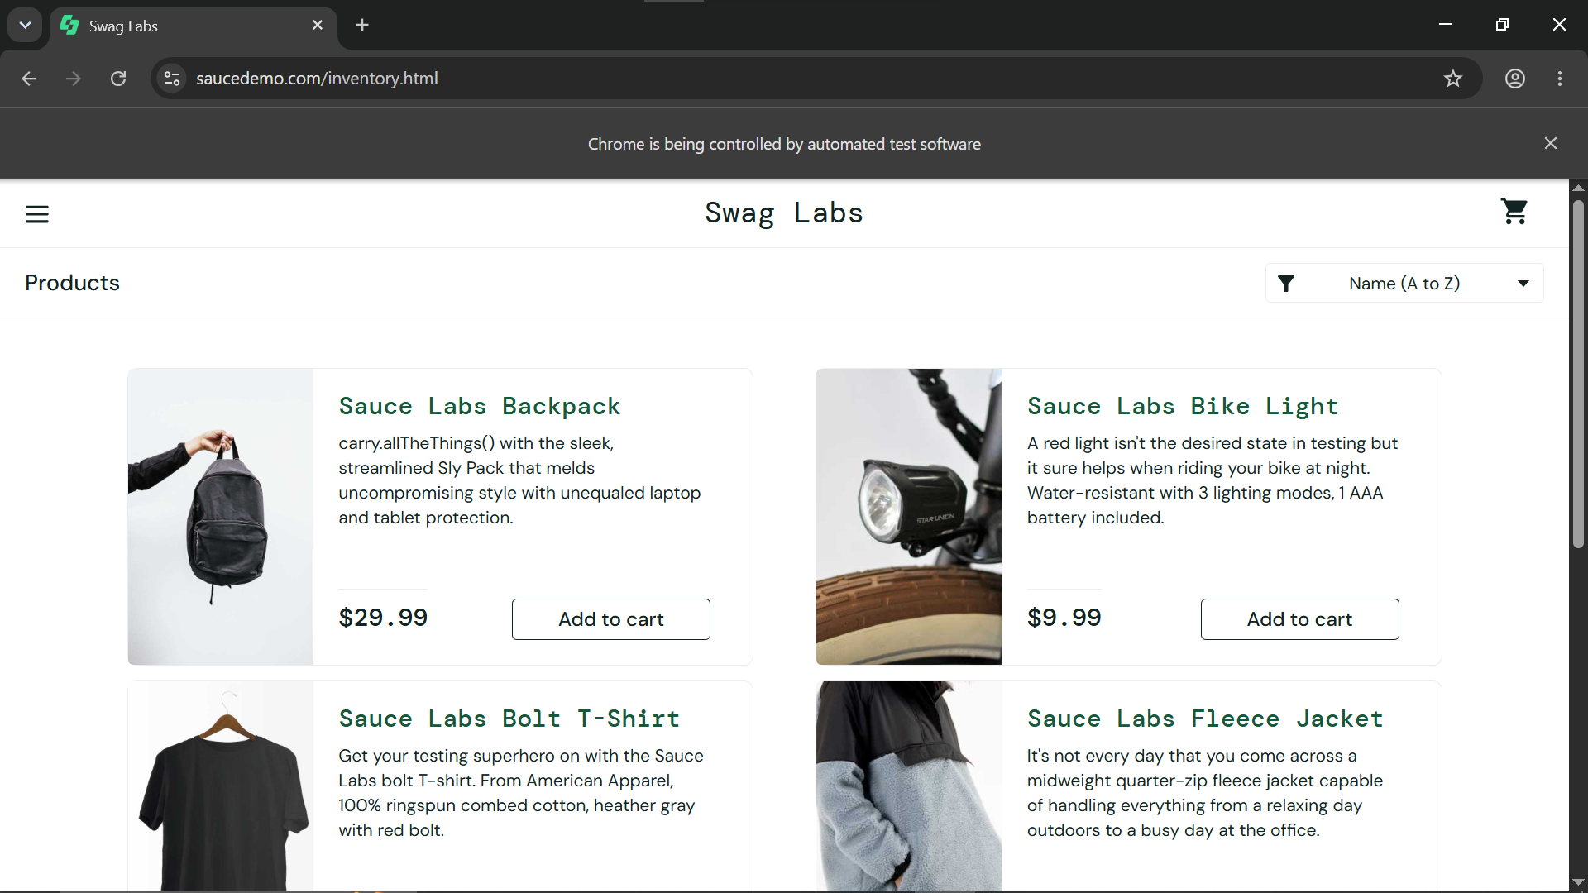

- Console Output:
